MIT School of Management, Pune
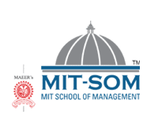

Netradeep M. Gursalkar  Mob.:+91- 9158241461  Email Id: deep.gs005@gmail.com  Course:MBA (Finance)  Date of Birth: 5th July 1990 | Current Address:  Kumar Prangan, C-23, near Warje Divisional Corporation office, Karvenagar, Pune  Pin code: 411052  Marital Status:Unmarried  Language Known:English, Hindi & Marathi | 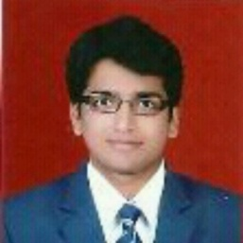

Educational Qualifications:
Education | Year of Passing | University /Board | Major Subjects | Percentage/CGPA
M.B.A.(Finance) | Pursuing | Savitribai Phule Pune University | Finance | 8.24(3rd Sem MBA)  8.00(1st year MBA)
B.E. | 2014 | Savitribai Phule Pune University | E&TC | 56.00 %
H.S.C. | 2008 | Maharashtra State Board | Science | 67.67 %
S.S.C. | 2006 | Maharashtra State Board | English | 70.80 %

Industry Internships:
Organization Name: Intelliquant Investment Modelling & Technologies Ltd., Mumbai
Title of Project: To create decision making model for value investor in Indian Stock Markets
Period: 23rd May 2016 To 5th Aug 2016
Key Learning/Outcome:
- Value Investing
- Stock Screening
- Perception of Indian investors

Certifications:
- NISM- Series XV- Research Analyst
- Financial Modelling by IMS Proschool
- Executive Excellence by Dale Carnegie Training India
- Business Simulation Workshop by enParadigm Knowledge Solutions
- German Language – A1

Key Skills:
Analytical Skills | Adaptive | Work-orinted | Strong grasping
Computer Skills:
MS Power Point | MS Excel | MS Word | SPSS Software
Co-Curricular Activities:

- Received Second Prize in REBEL – 2012 Paper presentation held in S.V.P.M’s College of Engineering, Baramati, Pune
- Received Second Prize in REBEL-12 Circuit Debugging Competition held in S.V.P.M’s College of Engineering, Baramati, Pune
- Participated in ELYSIUM – 2014 Robo-Race held in Vidya Pratishtan College of Engineering, Baramati, Pune

Extra Curricular and Interests:
- Achieved 1st runner up certificate in volleyball competition during academic year 2009-10
- Actively participated in organizing finance meet, Tour de globe, HR Paradigm, etc 2015

Book/s Read:
  - Rich dad poor dad by Robert Kiyosaki
  - Rokda – How Baniyas do Business by Nikhil Inamdar

Declaration:
I hereby declare that the above mentioned information is correct and true to the best of my knowledge.

Place: Pune (Netradeep M. Gursalkar)
Date:

